HA08 Data Description

Your file ha08_dataNN contains the following time series:
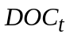 — expenditures on physicians (in billions of US dollars)
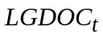 — logarithm of expenditures on physicians
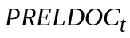 — relative price index of the servises of physicians
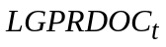 — logarithm of relative price index of the servises of physicians
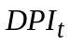— disposable personal income (in billions of US dollars)
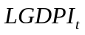 — its logarithm
All time series contain annual data for 1953-2003

